|  |  |
| --- | --- |
| **Assignment Case** |  |
| COMP6708016 Object Oriented Programming |
| **Computer Science** | **E223-COMP6708016-LC04308-02** |
| ***Valid on*** *Even Semester Year 2021/2022* | **Revision 00** |

## Soal

*Case*

**Arena Simulator**

**Arena Simulator** is a battle game between player and minion. You as a programmer are challenged to create the game with **JAVA** **Programming** **Language** using **Object** **Oriented** **Programming** **Concept** such as **Encapsulation**, **Inheritance**, and **Polymorphism**. The requirements for the application are as follows:

* The program consists of 5 menus:

1. **Add New Player**
2. **Delete A Player**
3. **View Player**
4. **Fight Minion**
5. **Exit**

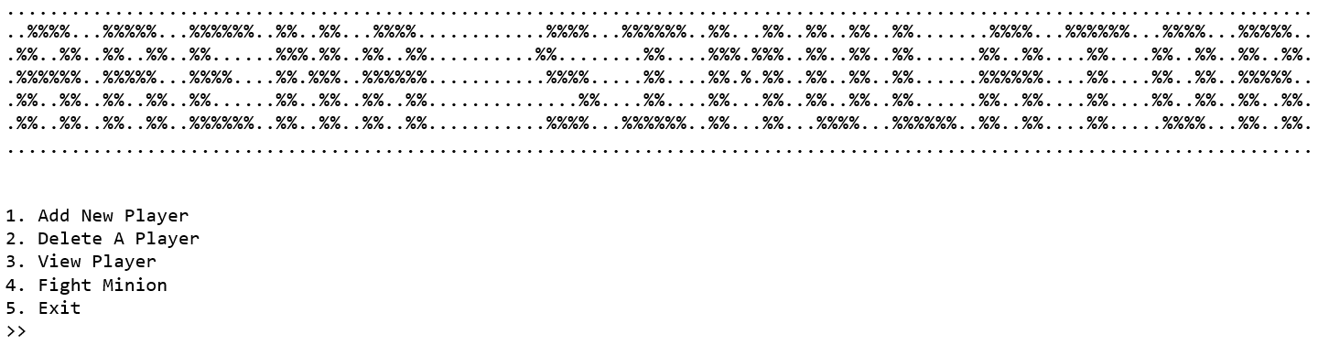

Figure . Main Menu

* If the user selected **menu 1 (Add New Player)**. Then:
  + The Game will ask user to input basic player information, which consists of:
    - **Player’s Name**, which needs to be **between 1 – 25 characters (Inclusive).**
    - **Characters Type**, which mustbe **either “Archer”, or “Warrior” (Case Sensitive)**.
  + Then, the game will **create a player which type either “Archer” or “Warrior”** with following initialization values:

|  |  |  |
| --- | --- | --- |
|  | **Warrior** | **Archer** |
| **Health** | 300 | 200 |
| **Shield** | 5 | - |
| **Range** | - | 5 |
| **Exp** | 0 | 0 |
| **Level** | 1 | 1 |

* + Then, the game will **save** all player’s information into a **list** (**ArrayList / Vector / Array**). Then, return to **main menu**.

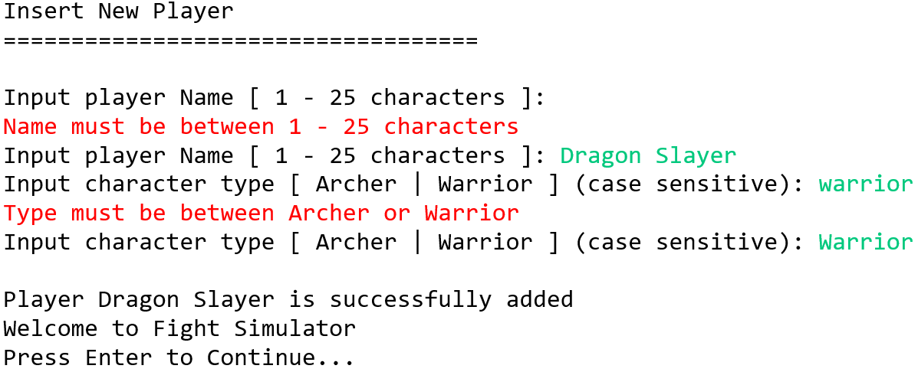

Figure . Add New Player

* If the user selected **menu 2 (Delete a Player)**. Then:
  + If there is no player in the list, **show following message**. Then, return to **main menu**.

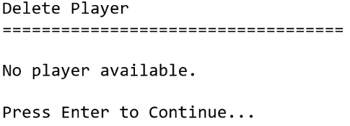

Figure . Delete a Player (Empty)

* + Otherwise, the game will **display all players’ details** including **Name**, **Type**, **Level**, and **Experience**.
  + Then, the game will ask user to select which **player** **to** **be** **removed** from the list. Validate the **value** must be **between 1 and total player data**.

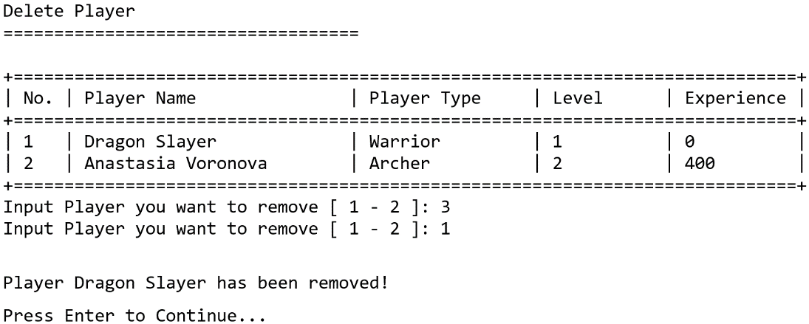

Figure . Delete a Player

* If the user selected **menu 3 (View Player)**. Then:
  + If there is no player in the list, **show following message**. Then, return to **main menu**.

Figure . View Player (Empty)

* + Otherwise, the game will **display all players’ details** including **Name**, **Type**, **Level**, and **Experience**.

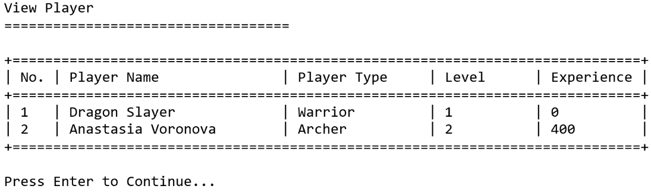

Figure . View Player

* If the user selected **menu 4 (Fight Minion)**. Then:
  + If there is no player in the list, **show following message**. Then, return to **main menu**.

Figure . Fight Minion (Empty)

* + Otherwise, the game will **display all players’ details** including **Name**, **Type**, **Level**, and **Experience**.
  + Then, the game will ask user to select which **player** **that they want to fight with** from the list. Validate the **value** must be **between 1 and total player data**.

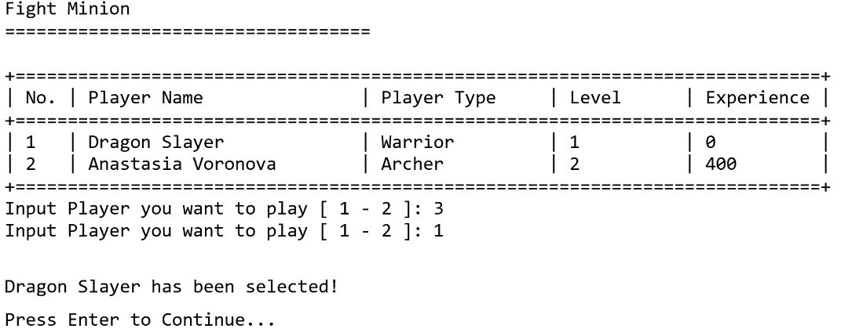

Figure . Fight Minion

* + Update the current health of player that was chosen from the list following the formula below:

|  |  |
| --- | --- |
| **Warrior** | **Archer** |
| Player HP = Level * 300 | Player HP = Level * 200 |

* + Then, the game will proceed to the **simulation** **menu**:

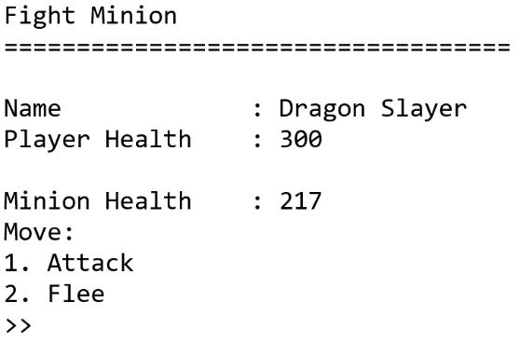

Figure . Fight Minion (Battle Simulation)

* + During the battle, **a player can move either “Attack” or “Flee”**.
    - If the player decided to “**flee**”. The game will return to **main menu**.
    - Otherwise, if the player decided to **attack**, there will be 2 turns. First, the player will attack the minion. After that, the minion will attack the player.

Note: Both actions reduce the **“defender” HP**. Please pay attention with formula below:

|  |  |  |  |
| --- | --- | --- | --- |
|  | **Minion** | **Warrior** | **Archer** |
| **Health** | Player’s Level * Random(100 – 200) | Characters current Health | Characters current Health |
| **Attack** | Random(0 – 60) | Random(0 – 50) | Random(0 – 50) + Range |
| **Damage Taken** | Player Attack | Enemy Attack - Shield | Enemy Attack |

* + - **Repeat the process** **starting from** **asking the player to choose either “Attack” or “Flee”** until **either the player or the minion is killed** or until **the player choose to “Flee”**.
    - If the minion defeats the player, **remove the player that was chosen from the list** and **return to the main menu after displaying the message.**

Figure . Fight Minion (Player Defeated)

* + - If the player defeats the minion, **player will gain Experience the same amount as enemy’s HP**.
    - Then, **check player for level up based on formula below**. If the player level up, **the game will update player’s health based on the formula below** and **return to the main menu after displaying the message**.

|  |  |  |
| --- | --- | --- |
|  | **Warrior** | **Archer** |
| **Level Up** | PlayerExp = PlayerExp + MinionHealth  ExpToLevelUp = Level * 500  E.g., For leveling up to level 4 you need 1500 exp (3 * 500exp)  If **PlayerExp** greater than or equals with **ExpToLevelUp**   * + - * **Increase Player Level by 1**       * **Set Player Experience to 0** | |
| **Player Status** | Player HP = Level * 300 | Player HP = Level * 200 |

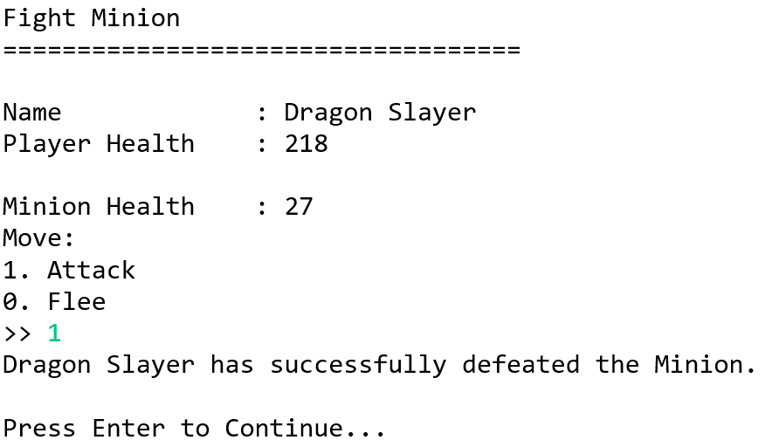

Figure . Fight Minion (Player Victory)

* If the user selected **Menu 5 (Exit)**. The program will **exit**.

**If you need any assistance, kindly ask your assistants for help.**